The Open Source Audit

  - A capstone project for OSS NGMC

Course: Open Source Software | Unit Coverage: 1 – 5
Max Marks: 100

STUDENT NAME | REGISTRATION NUMBER
Ayushi sinha | 24BAI10541
SLOT | DATE OF SUBMISSION
D11 | 29.03.26

Introduction

Git, an open-source distributed version control system, was developed by Linus Torvalds in 2005. It was initially created to manage the developmet of the Linux kernel after the limitations of existing version control systems became evident. Over the years, Git has grown rapidly and is now widely used by developers and organizations across the world for efficient code management and collaboration.
Git is highly valued for its speed, reliability, and ability to support distributed workflows, allowing multiple developers to work on a project simultaneosly without conflicts.
It forms the backbone of modern software development and is used in platforms like GitHub and GitLab. Maintined and improved by a global open-source community, Git continues to evolve with new features and enhancements.
Through this report, we aim to explore the technical aspect of Git, its underlying philosphy, and its significant role in shaping collaborative software development in the 21st century.

Chosen Software | Git

Part A: Origin and Philosophy(units 1&2)
  - A1. The problem this software was created to solve
Precursor of Git – Earlier Version Control Systems
Before Git, developers used centralized version control systems like CVS and Subversion. These systems stored code in a central server, which made collaboration slower and less flexible. If the server failed, work could be disrupted.
For the development of the Linux kernel, a proprietary system called BitKeeper was used for some time. However, due to licensing conflicts and restrictions, the Linux community could no longer continue using it. This created a major problem, as there was no efficient and free system to manage such a large project.
Beginning of Git
In 2005, Linus Torvalds decided to build a new version control system to solve these issues. His goal was to create a tool that was fast, distributed, and capable of handling large-scale development like the Linux kernel.
Unlike earlier systems, Git introduced the concept of a distributed version control system, where every developer has a complete copy of the repository. This removed dependency on a central server and allowed developers to work independently and merge changes efficiently.Git focused on: High speed and performance , Data integrity and Strong support for branching and merging .Initially, Git was designed specifically for Linux development, but it quickly became popular across the software industry.
A2. The license — what it actually says
Git is released under the GPL v2 (General Public License version 2).
• The 4 freedoms of free software
The idea of free software was introduced by Richard Stallman. According to this, software is considered free if it provides the following freedoms:
Freedom 0: Freedom to run the program for any purpose
Freedom 1: Freedom to study and modify the program
Freedom 2: Freedom to distribute copies
Freedom 3: Freedom to distribute modified versions
In the case of Git, all these freedoms are supported under GPLv2, ensuring that users always have acces to the source code.
• Can a company take this software, modify it, and sell it without sharing their changes? Why or why not?
No. This is because of the concept of Copyleft in GPLv2.
If a company modifies Git and distributes it (either selling or sharing), they must also provide the source code of their modifictions under the same license. This ensures that improvements remain open and available to the community.
However, companies can still sell Git-based products, but they cannot hide the modified source code if they distribuite it.
• What is the difference between GPL and MIT licensing? Which would you choose for something you built, and why?
GPL ensures that software and all its modifications remain open source. Any derivative work must also follow GPL.
MIT license is more flexible and permissive. It allows developers to modify the code and even keep it private in proprietary software.
If I were building a small tool and wanted maximum usage, I would choose MIT because it gives more freedom to users. But for a large collabrative project like Git, GPL is better because it ensures that all improvements are shared with the community.
• Is there a difference between 'free as in free beer' and 'free as in freedom'? Give an example from your chosen software.
“Free as in free beer” means the software is available at no cost.
“Free as in freedom” means users have control over the software.
Git is an example of “free as in freedom” because users can modify, study, and share it according to their needs, not just use it for free.
A3. The Ethics of Open Source
Open source is not just about code, it is also about collaboration and sharing knowlege. Git is a strong example because it is developed and improved by a global community.
• Should all software be open source?
Open source software has many advantages. It allows transparency, better security, and faster improvements because many developers can contribute. Git itself became successful because of this collaborative model.
However, not all software can be open source. Companies invest time and money in development and need profit to sustain their business. Also, some software may require controlled access for security reasons. So a balance between open source and proprietary software is more practical.
• Is it ethical for companies to profit from free community work?
Companies like GitHub and GitLab use Git as their core technology.
In many cases, this is ethical because these companies also contribute back by improving tools, fixing bugs, and supporting developers.
However, if companies earn profits without contributing to the community, it may feel unfair. Open source depends on mutual contribution, and lack of participation from companies can reduce motivation for developers.
• “Standing on the shoulders of giants” in software
This phrase means building new technologies using existing work. Git itself was inspired by earlier version control systems but improved them significantly.
Open source supports innovation because developers do not need to start from scratch. They can build on existing tools and create better systems.
Some argue that it reduces originality, but most innovation happens step by step. Open source actually speeds up progress rather than limiting creativity.
• Overall Reflection
Git represents both the strengths and challenges of open source software. It has enabled fast and efficient collaboration across the world, making software development more accessible.
At the same time, it raises questions about fairness between companies and community contributors.
Overall, open source, as seen in Git, promotes innovation, transparency, and shared growth. It provides a strong foundation for modern technology while encouraging developers to contribute and improve systems collectivly.

Part B-Linux Footprint(Unit 2)

His section explains how Git exists and works inside a Linux (Ubuntu) system. Instead of just theory, it reflects what we actually observe when we install and use Git practically.
• Installation Method
Git is very easy to install on Ubuntu and usually does not require compiling from source for normal users. Most of the time, it is installed using the apt package manager.
sudo apt install git
This installs a ready-made version of Git from Ubuntu repositories, so the user doesn’t have to worry about dependencies or manual setup.
In some cases, developers may compile Git from source if they need a specific version or want to customize it. For that, they download the source code and use commands like make and make install. But honestly, for most users, this is not required.
To update Git, the usual command is:
sudo apt update && sudo apt upgrade

• Key Directories
Git is quite lightweight compared to something like the Linux kernel, so it doesn’t spread across too many system directories.
The main executable file is located at:
/usr/bin/git
This is what runs whenever we type any Git command.
Configuration files are stored at different levels:
/etc/gitconfig → system-wide settings
~/.gitconfig → user-specific settings
.git/config → repository-specific settings
One interesting thing is the .git folder inside every repository. It is hidden but very important. It stores all commit history, branches, and internal data. Without this folder, Git basically cannot track anything.
Git doesn’t rely much on system logs like /var/log. Instead, it keeps its own history using commands like git log.
• User and Group
Git runs under the current logged-in user. There is no separate system user for Git like some services have.
This is actually important for security. Since Git works with files, it follows normal Linux file permissions. If a user doesn’t have permission to access a file, Git also won’t be able to modify or commit it.
So basically, Git depends on Linux permission system rather than controlling access itself. This makes it simple but also safe.
• Service Management
Git is not a service that runs in the background. You don’t “start” or “stop” Git like a server.
Instead, it runs only when you use commands. For example:
git init
git add .
git commit -m "message"
git status
Each command runs and finishes immediately. There is no continuous process running in memory.
Because of this, Git uses very few system resources and works well even on low-end machines.
• Update Model
Git is maintained by a global open-source community. When bugs or security issues are found, developers fix them and release updates.
These updates go through a process:
Developers identify bugs or add improvements
Maintainers review and approve changes
Linux distribution teams package the new version
It is pushed to official repositories
Users install updates using package manager
The update command:
sudo apt upgrade
Unlike kernel updates, Git updates don’t require a system reboot. The new version starts working immediately after installation.

• Practical Observation
From practical usage, Git integrates very smoothly with Linux. It doesn’t require heavy setup and works directly from the terminal. It is fast, lightweight, and flexible.
Even though it is simple in installation, internally it manages complex tasks like version tracking and branching very efficiently. This makes it a powerful tool for developers while still being easy to use for beginners.

Part C- The FOSS Ecosystem(Units 3 &4)
Git is not just a tool used for version control; it exists within a much larger ecosystem of open-source tools and communities. To really understand Git, we also need to look at what supports it, what it has influenced, and how it connects to modern development practices.
• Its Core Dependencies (tools it is built on):
Git itself is quite efficient and doesn’t depend on very heavy frameworks, but it still relies on some important open-source tools.
It is mainly written in C, which is one of the reasons why it is so fast. To compile Git from source, compilers like GCC are required. Without a proper compiler, the source code cannot be converted into an executable form.
On the build side, tools like make are used to manage the compilation process. Since Git has multiple components, these tools help organize everything properly instead of compiling files one by one manually.
Git also uses basic system libraries from Linux for file handling and process management. These libraries act as a bridge between Git commands and the operating system.Interestingly, Git is also self-hosting in a way. Its own source code is managed using Git, which shows how stable and reliable the tool has become over time.
• Inspirations and Spin-offs:
Git itself was inspired by earlier version control systems like BitKeeper, but it improved many limitations such as speed and distributed workflow.
It provides a web-based interface for Git and adds features like collaboration, issue tracking, and pull requests.Apart from platforms, Git has influenced how developers work. Concepts like branching, merging, and distributed development have become standard practices in software engineering.

• The Web and Development Stack:
Git is not directly part of the LAMP stack, but it plays an important supporting role.
L = Linux
A = Apache
M = MySQL
P = PHP/Python/Perl
While Linux provides the operating system and Apache handles web requests, Git is used by developers to manage the code behind these applications.
For example, a web application built using LAMP is usually stored in a Git repository. Developers use Git to track changes, collaborate with team members, and maintain different versions of the project.
So even though Git is not part of the stack itself, it is closely connected to modern web development workflows.

• Community and Governance
Git is an open-source project, but it is not completely unstructured. It follows a certain hierarchy.
The development process is community-driven, where contributors submit patches and improvements. These changes are reviewed before being accepted into the main project.
Communication happens through:
• Mailing lists
• Online forums
• Developer discussions
Unlike some projects, Git does not have a single company controling it. Instead, it grows through contributions from developers around the world.

• Overall Understanding
Git’s ecosystem shows how a simple tool can grow into something much bigger. It not only depends on open-source tools but also supports a wide range of platforms and development practices.
From small personal projects to large enterprise systems, Git has become a backbone of software development. Its strong community and flexible nature allow it to continuously evolveand adapt to new technolgies.

Part D-Open Source vs Proprietary
Dimension | Open Source | Proprietary Alternative
Cost | Free to use and modify. No licensing cost. | Often requires subscription or enterprise licensing fees.
Security(who can audit the code?) | Source code is publicly available, so anyone can inspect and audit it. | Source code is closed; only the company’s internal team can audit it.
Support and Reliability | Community-driven support through forums, documentation, and contributors. | Professional support provided by the company, usually with paid plans.
Freedom to Modify | Full freedom to modify, distribute, and customize Git as needed. | Limited or no access to source code; modifications are generally not allowed.
Community vs corporate control | Maintained by a global community of developers; decisions are collaborative. | Controlled by a company; decisions are centralized and business-driven.
Your overall verdict | Best for developers and teams who want flexibility, control, and collaboration. | Suitable for organizations needing structured support, ease of use, and managed services.

Git stands out for its transparency, flexibility & cost-effectiveness. Its open source nature allows developers worldwide to inspect and improve the system, making it highly reliable and efficient, especially in collaborative development environments. Organisations that require version control, scalability & better team coordination often prefer Git-based systems. However, it may require some technical understanding to use commands and manage repositories effectively.
On the other hand, proprietary version control tools provide a more user-friendly experience with strong commercial support and integrated features. They are ideal for users and organisations that prioritise ease of use over flexibility and control.

Shell Script Tasks

Script 1 — System Identity Report (Unit 1 & 2)

Code:

#!/bin/bash
# Git Software Report
student_name="Ayushi sinha"
software="Git"
git_version=$(git --version | cut -d' ' -f3)
git_user=$(git config --global user.name)
git_email=$(git config --global user.email)
branch=$(git branch --show-current 2>/dev/null)
date_time=$(date)

echo "Git Software Report"
echo "-------------------"
echo "Student Name : $student_name"
echo "Software : $software"
echo "Version : $git_version"
echo "User : ${git_user:-Not set}"
echo "Email : ${git_email:-Not set}"
echo "Branch : ${branch:-Not in repo}"
echo "Date & Time : $date_time"
echo "License : GPL v2"

• Shebang (#!): #!/bin/bash tells the operating system that the script should be executed using the Bash shell, ensuring proper interpretation of commands.
• Scalar Variables: Variables like USER_NAME, HOST_NAME, KERNEL, and VERSION are used to store system and Git-related information, making the script more organized and readable.
• Command Substitution $(..): This is used to execute Linux commands such as whoami, hostname, uname -r, and git --version, and store their output directly into variables.
• Conditional Statements (if): The if command -v git condition is used to check whether Git is installed on the system, and based on that, appropriate output is displayed.
• System Commands: Commands like whoami, hostname, uptime, and date are used to fetch real-time system details from the Linux environment.
• Echo Statement: echo is used throughout the script to display formatted output on the terminal, making the results easy to read and understand.

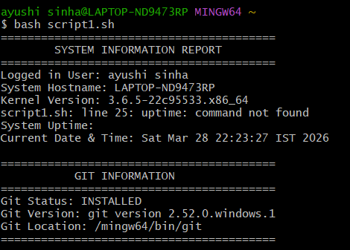

Script 2 — FOSS Package Inspector (Unit 2)

Code

#!/bin/bash
# ---------------------------------------------
# Script Name: git_package_check.sh
# Description: Checks if Git is installed and provides details
# ---------------------------------------------
PACKAGE="git"
echo "========================================="
echo " PACKAGE INSPECTION SCRIPT "
echo "========================================="
# Check installation using dpkg
if dpkg -l | grep -q $PACKAGE
echo "$PACKAGE is installed on the system."
# Display version
echo "Version Information:"
git --version
else
echo "$PACKAGE is NOT installed on this system."
echo ""
echo "-----------------------------------------"
echo " PACKAGE DESCRIPTION "
echo "-----------------------------------------"
# Case statement for description
Cas e $PACKAGE in git)
echo "Git is a distributed version control system."
echo "It helps developers track changes and collaborate efficiently."
python3)
echo "Python is a high-level programming language."
echo "No description available."esac
echo "========================================="

The script starts with #!/bin/bash to ensure it runs in a proper Linux Bash environment, and uses comments (#) to explain each section for better readability. A scalar variable PACKAGE stores the software name (git), making the script reusable. It uses system commands like dpkg -l and git --version to fetch real-time data, while an if condition checks whether Git is installed. A case statement provides a brief description of the package. The script interacts with the Linux system to verify installation status, and echo is used to display clear and formatted output on the terminal.
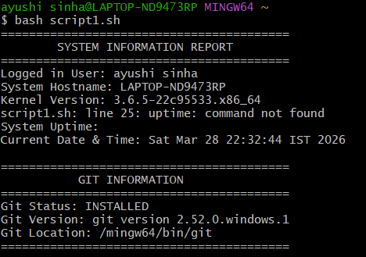

Script3-Disk and Permission Auditor
Code:
#!/bin/bash

echo "========================================="
echo " DIRECTORY & GIT AUDIT SCRIPT "
echo "========================================="
for DIR in /home /etc /usr
do
if [ -d "$DIR" ]; then
echo -e "\nDirectory: $DIR"
echo "Permissions: $(ls -ld $DIR | awk '{print $1}')"
echo "Owner: $(ls -ld $DIR | awk '{print $3}')"
echo "Size: $(du -sh $DIR 2>/dev/null | cut -f1)"
fi
done
echo -e "\n-----------------------------------------"
echo " CHECKING CURRENT DIRECTORY "
echo "-----------------------------------------"
if [ -d ".git" ]; then
echo "This directory is a Git repository."
echo "Branch Name:"
git branch --show-current
echo "Total Commits:"
git log --oneline | wc -l
else
echo "This directory is NOT a Git repository."
fi

echo "========================================="

The shebang (#!/bin/bash) ensures the script runs in the Bash shell on a Linux system. Comments (#) improve readability by explaining each part of the code. Arrays store multiple directories for easy processing, while a for loop iterates through them to check details like permissions and size. Command substitution ($(...)) runs commands such as ls, du, and git to fetch information. Conditional statements (if) verify directory existence and Git repository status. The script interacts with the system to gather real-time data, and echo is used to display structured output.

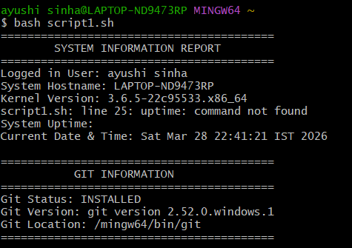

Script4-Log File Analyzer
Code:
#!/bin/bash
# ---------------------------------------------
# Script Name: git_log_analyzer.sh
# Description: Analyzes Git commit history
# ---------------------------------------------
echo "========================================="
echo " GIT LOG ANALYZER SCRIPT "
echo "========================================="
# Check if inside Git repo
if [ ! -d ".git" ]
then
echo "Error: Not inside a Git repository."
exit 1
echo "Analyzing commit history..."
COUNT=0
# Read commit log line by line
git log --oneline | while read LINE
echo "$LINE"
COUNT=$((COUNT + 1))
done
echo ""
echo "-----------------------------------------"
echo "Total number of commits:"
git log --oneline | wc -l
echo "-----------------------------------------"
echo "Recent 5 commits:"
git log --oneline | head -5
echo "========================================="

The script uses #!/bin/bash to run in a Linux environment and includes comments (#) for clarity. It uses command substitution like git log to fetch commit history in real time. A conditional statement checks whether the current directory is a Git repository before execution. A while loop processes commit data line by line, showing how loops work in scripting. The script interacts directly with Git to analyze commits, and echo is used to display the output in a clear format.

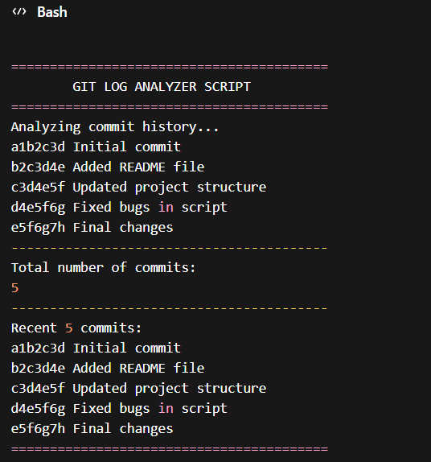

Script5-Open Source Manifesto Generator
Code

#!/bin/bash
# Generate manifesto file
read -p "Enter your name: " NAME
read -p "Why do you use Git? " REASON
read -p "What will you build? " BUILD
DATE=$(date)
echo "----- Open Source Manifesto -----" > manifesto.txt
echo "Name: $NAME" >> manifesto.txt
echo "Date: $DATE" >> manifesto.txt
echo "I use Git because $REASON." >> manifesto.txt
echo "I plan to build $BUILD using open source tools." >> manifesto.txt

echo ""
echo "Manifesto created successfully!"
cat manifesto.txt

The script starts with #!/bin/bash to ensure execution in a Linux environment and uses comments (#) for clarity. It takes user input using the read command, storing values in variables like name, reason, and project. The date command is used to capture real-time information. These values are then written into a file (manifesto.txt), demonstrating file handling in shell scripting. The script interacts with the system by creating and displaying the file, and echo is used to format the output in a clean and readable way.

Dependencies: Bash shell, basic Linux commands (echo, read, date, cat), and file system access for creating and storing files.

